**Mobile Application Development**

We develop Mobile Applications that not only increase productivity but also provide experiences that enable business growth

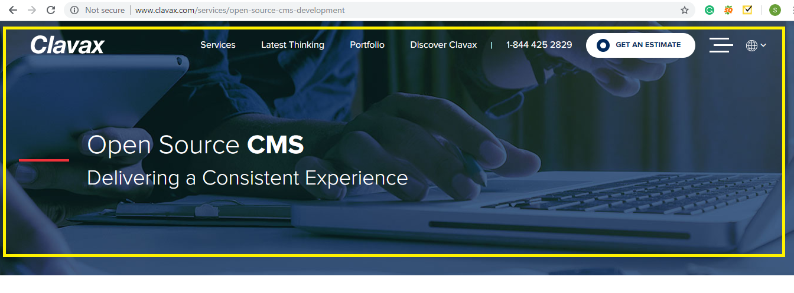

It is perfectly clear that the interest for mobile applications has raised in all organizations. To adapt to that, we turn into your quickening accelerator to outline and create splendid mobile applications. Nunc Systems is an emerging Indian Mobile App Development Company, delivering diversified Mobile App experiences. Situated in Hyderabad, Nunc Systems emerged as one of the Top Mobile Application Development Company in a shorter span.

Ideal from Mobile Strategy to Mobile Applications Design and Development to Mobile Testing and Deployment, we cling to demonstrated worldwide guidelines and system to convey top positioning mobile applications.

**>>Next**

Why Nunc?

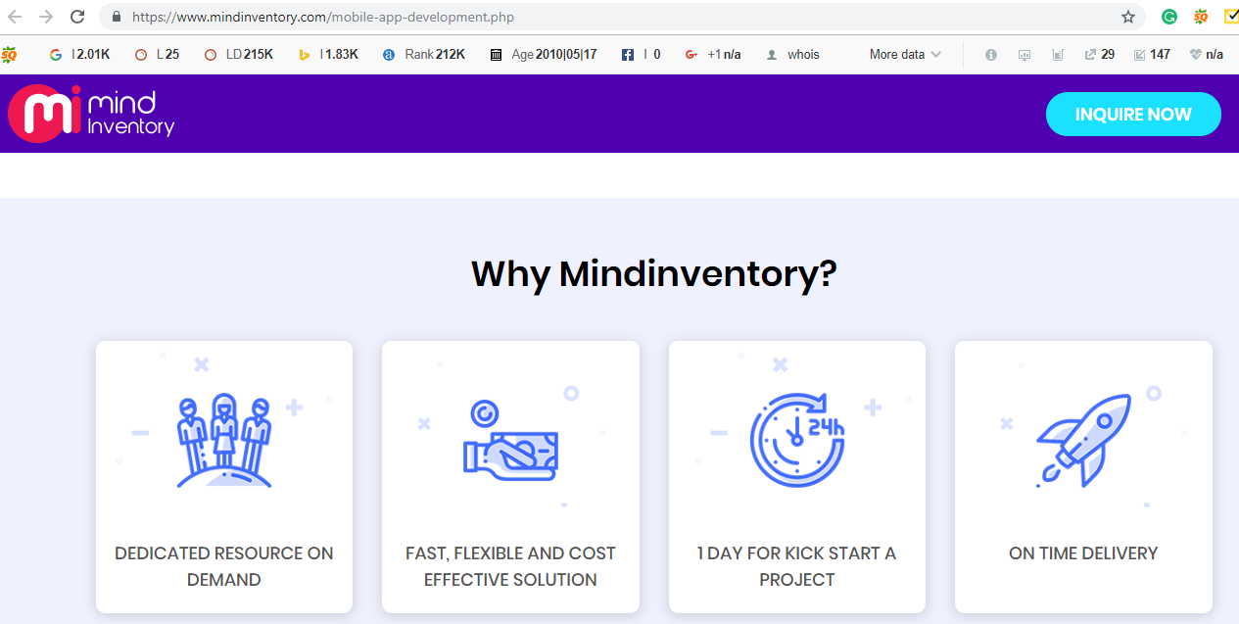

Our mobile application team has profoundly met all requirements to convey the full scope of mobile services. We hold a prominent position as a Mobile Application Development Company for developing mobile applications for various sectors and by modulating components in an application that support development, issues effective and industry standard techniques. As per your needs and requirement for a mobile application we aim to provide you with the solutions that best suits your business when your needs meet our expertise, it results are ultimate quality solutions.

Our aptitude to provide quality mobile applications to the list of the best mobile software providers in Australia has added value to our service offerings. Our dedication towards developing a quality product makes us have an edge over others. Nunc Systems provides a wide variety in Mobile Application Development that encompasses the entire mobile application development cycle from initial design and architecture to development and integration into existing systems.

**>>Next**

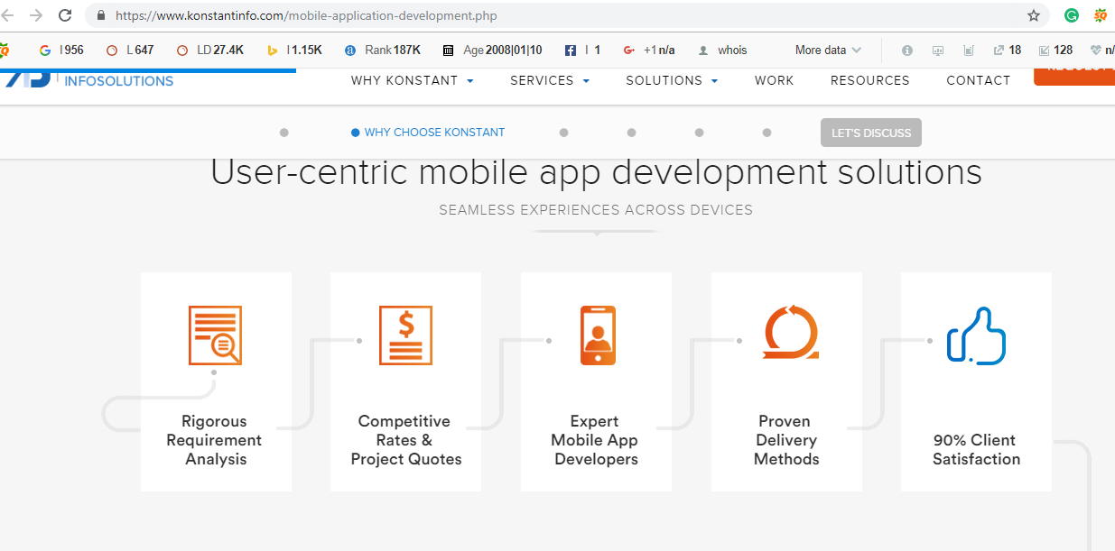

Text to be used

**User-Driven Mobile Application Development Solutions**

**Next>>**

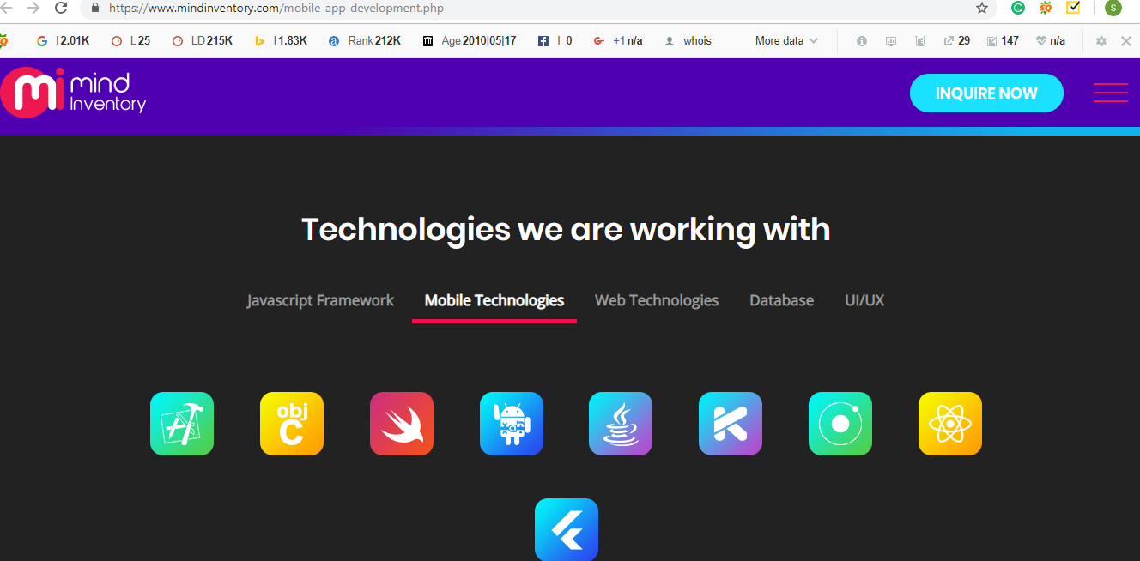

Nunc Systems is a best-in-class mobile application development company offering mobile application development services for Android iPhone, and iPad.

Areas we are master in:

* We make User-friendly designs
* Our Applications support and maintenance
* We provide Reliable and cost effective mobile applications
* We Provide active services to various platforms

>>Next

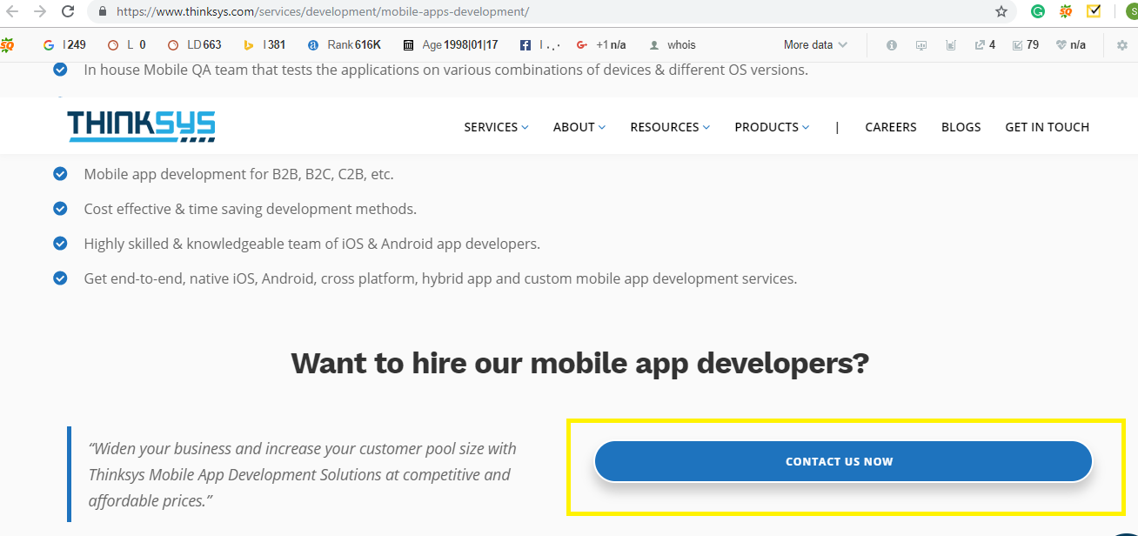

Text to be used

**Contact us today to know more about what we can do for your business: {When we click on contact us a query form should open}**